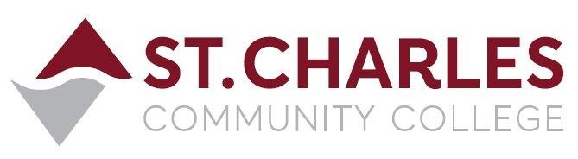

ST. CHARLES COMMUNITY COLLEGE
Campus Police Outreach Task Force
Wednesday February 10, 2021 at 11:30am
Meeting via Zoom Conference

MEETING MINUTES

Present: Jeff Drake (Chair) Campus Police
Brandon Misher Campus Police
Martha Kampen Human Resources
Robert Jones Student Life
Rocio Romero Student

- Welcome / Introductions Jeff and Brandon

- Recap of last meeting Robert, Martha
- Robert considered more personal interaction between students and police officers to build understanding and trust, that building relationships would be the most effective way to encourage students to share their ideas and concerns openly and without hesitation. He also thought as we plan guest speakers or other presentations, we should send out a meeting agenda to the entire group so they know what date and time the special guest will be presenting – the hope is this would increase interest and encourage more students to attend the meetings.
- Martha agreed that a more comfortable human relationship would encourage students to share their thoughts and ideas, and to feel safe to pose questions or comments that they have about our police department or police work in general, whether positive or negative.

- Sharing Ideas Rocio, Jeff, Robert
- Rocio said she had spoken to several friends and that they were interested in the concept of this forum for communication between the police department and students. She said one of her friends wanted to participate in future meetings. Rocio was encouraged to share the meeting link with her friend so she can join us and potentially become a member of the Task Force as well. Rocio also thought these meetings and other possible in-person events would be a good way to establish better understanding and an alliance between the police and minorities and other diverse groups.
- Jeff mentioned that since there were students enrolled in criminal justice related courses at SCC, the police department could host some kind of meet-and-greet forum with brochures and officers present to answer questions about the law enforcement as a possible career.
- Robert said that during the next Student Activities sponsored professional development forum he will include the Campus Police as one of the professions represented at the event.

- Guest Speakers / Presentations Robert, Martha, Jeff, Brandon
- Members of the group were in agreement that guest speakers should engage the group meetings with a variety of topics.
- Robert suggested presenters to speak on mental health, suicide prevention and awareness, drug overdoses, and other issues facing young people.
- Martha suggested said that since students were required to be online so much more during the pandemic, advice and instruction on cyber-bullying and staying safe online would be good topics to be offered from outside experts.
- Jeff advised the group that Campus Police Chief Bob Ronkoski was currently attempting to schedule a guest speaker who is an African American Police Chaplain, who can offer his experiences dealing with the good and bad situations involving police officers and the public, offering a perspective from the police and the public side of these encounters.
- Brandon suggested basic first aid and CPR as possible topics for meeting presentations, and basic student safety advice and suggestions – similar to the presentations the Campus Police gives to the International Student classes each semester.

- Closing comments from the group The Group
- Jeff said that since Wednesday appeared to not be the best day of the week to have the Task Force meeting due to a conflict with many students’ class schedules, he would return to a Friday meeting schedule beginning with this Friday February 12th, and a new Zoom invite would be sent to all task force members. The group will collaborate on the best times for the meetings so we can have the maximum student participation.

Next meeting: Friday February 12, 2021 at 11:30am via Zoom.

