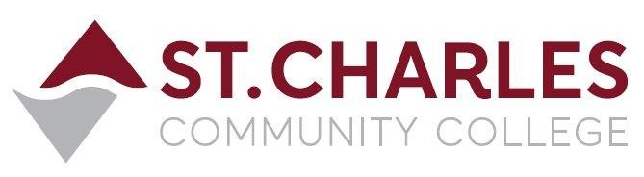

ST. CHARLES COMMUNITY COLLEGE
Campus Police Outreach Task Force
Wednesday March 24th, 2021 at 6:00pm
Meeting via Zoom Conference
MEETING MINUTES

Present: Jeff Drake (Chair) Campus Police
Brandon Misher Campus Police
Martha Garcia Kampen Chief Diversity Officer
Abigail James Student
Stephen Temple II Student
Rocio Romero Student
Jiewon Jeong Student

- Welcome / Introductions Group
- Task Force participants arrived and we greeted one another.

- Recap of last meeting Jeff, Brandon and Martha
- We recalled the discussions at the last meeting, which mostly were about the new meeting time on Wednesday at 6:00pm, which did allow more students to participate tonight, and a reminder for students to always keep thinking of topics they’d like to cover in the meetings.

- Discussion on Mental Health Group
- Martha shared her screen with the group, working on a promotional poster for the upcoming presentation by Kyle Dooley of NAMI. She worked on it as the group discussed the topic and possible questions the students might have for Kyle.
- Rocio was curious how many police officers really appreciate and embrace the CIT training rather than just taking the training because they have no choice. The group agreed that was a good question for Kyle.
- Jiewon was curious if a person who does not seek professional treatment for a mental health problem, could it lead to them committing a crime? She also said bullying had become a serious issue in Korea and that the victims began to speak out and write things that spurred the government to take bullying more seriously.
- Rocio commented on the recent mass murder of Asian women on March 16th in Atlanta. She wondered if the suspect might use mental illness as a defense when it appeared to be more of a hate crime. The group discussed the possibilities.
- Martha noted that one mental health issue caused by the COVID pandemic has been people’s reluctance or inability to have close physical contact or hug one another, which is a very important thing for so many people.

- Meeting times Group
- Since more students were able to make this meeting at 6:00pm, Jeff said the next meeting will be re-scheduled from Friday April 9th at 2:30pm to Wednesday April 7th at 6:00pm. The group agreed this would be a good idea.
- Since Kyle Dooley is in such high demand for his presentations and was difficult to get scheduled for Friday April 23rd at 2:30pm, we decided not to try to switch his presentation to another time or date – however the presentation will be recorded and a link offered to anyone who wants to view it at a later time.
- Martha suggested that since we will be marketing Kyle’s presentation outside the college that it might be accessible to a larger audience if it were a Facebook Live event. The group agreed and Martha will consult with Marketing to see how that could be set up. It was not decided yet if we will consider his presentation as our late April meeting or if we will have another one on the previous Wednesday evening. We tabled this for the next meeting.
- We also tabled the agenda item regarding safety tips for students as this meeting ran longer than usual. We will discuss this topic at the April 7th meeting.

- Closing comments from the group.
- We liked the poster that Martha had screen-shared and she will be meeting with Marketing to get it completed and published / displayed. Martha suggested adding Multicultural to our group name since we are trying to make the outreach efforts bridge cultural differences and foster understanding between the police and other cultures. The group members were fine with that change.

Next meeting is Wednesday April 7th, 2021 at 6:00pm via Zoom

