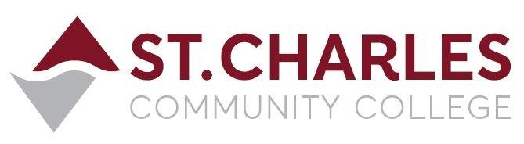

ST. CHARLES COMMUNITY COLLEGE
Campus Police Outreach Task Force
Friday – January 29, 2021 at 2:30pm
Meeting via Zoom Conference

MEETING MINUTES

Present: Bob Ronkoski Campus Police
Jeff Drake (Chair) Campus Police
Brandon Misher Campus Police
Martha Kampen Human Resources
Robert Jones Student Life
Jiewon Jeong Student
Rocio Romero Student
Luis Sanchez Student
Alexis Finney Student
Abigail James Student

- Welcome / Introductions Bob / The Group

- Purpose of Task Force Jeff

- To create an opportunity for the open exchange of ideas and perspectives between students and police officers about campus policing.
- To identify opportunities to demonstrate leadership in fostering strong relationships between students and the Campus Police.
- To discuss current social issues impacting the community, region and nation.

- Services offered by Campus Police Department Bob, Jeff, Brandon
- Vehicle assist (jump start, keys locked in car, tires, gasoline)
- Access to locked rooms to retrieve items
- Lost and Found at our station
- Escorts to and from vehicles anytime
- Emergency Phones in hallways, parking lots, apartments
- Sign up for text message alerts: www.stchas.edu/text
- Officers CIT trained – crisis intervention, referrals for help
- First aid and CPR trained – assist with medical / injury
- Active Shooter Response training for students and staff

- Community Involvement Bob and Jeff
- A brief explanation of the interaction between our Police Department and neighboring communities, such as fundraising softball games to raise money for the CARE Team emergency fund for students in crisis, helping with the annual St. Pat’s Parade in Cottleville, and involvement with meet and greet families and kids during Food Truck Frolic and other family activities on the college campus.

- Ongoing training for our officers Bob, Jeff, Brandon
- Chief and officers gave examples of the ongoing education and training our department receives in areas such as cultural awareness, racial profiling, trauma training, de-escalation techniques, implicit bias, and many other socially relevant topics that affect how we deliver services to the community. Brandon explained that after the police academy, officers’ training does not stop, and that we receive ongoing education and training each year for the remainder of our careers.

- Questions or Concerns Robert, Martha, Bob
- Robert Jones suggested an all-student text message if possible to let the students know the phone number to reach Campus Police so they can add it to their phone contacts. Martha Kampen thought that Dave Leenhouts might have a way to initiate a mass text message, and she will follow up on that.
- Bob had a “homework assignment” for the group, to think about what they would like the Task Force to be, what topics they might like to discuss, if they have an outside speaker they might like to have talk to the group, and what they would like for us to accomplish as a group.
- Martha suggested the students in the group mention it to their friends for ideas that they might like us to engage. Robert suggested the SGA students could put together something and reach out to students for their input as well.

- February Meetings and beyond Jeff

- Jeff advised the group that we will schedule meetings twice monthly through the end of the Spring Semester. The next meeting will be scheduled soon after some input from the group, possible date Friday February 12th at 2:30pm via the Zoom Conference format.

