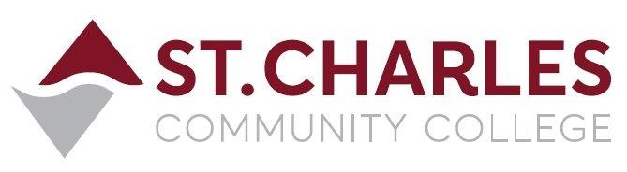

ST. CHARLES COMMUNITY COLLEGE
Campus Police Outreach Task Force
Wednesday May 19th, 2021 at 6:00pm
Meeting via Zoom Conference
MEETING MINUTES

Present: Jeff Drake (Chair) Campus Police
Brandon Misher Campus Police
Rocio Romero Student
Jiewon Jeong Student

- Welcome / Introductions Group
- Task Force participants arrived and we greeted one another.

- Recap of this semester’s Task Force meetings Jeff and Brandon
- Jeff and Brandon recapped the Spring Semester task force meetings by topics discussed, including outside speakers Bryon Watson and Kyle Dooley. Topics included crime prevention, staying safe online and out with friends, asking friends and peers to offer suggestions for new topics for the task force to discuss, hot weather travel safety tips, tornado season safety, heat related illnesses and treatments, Crisis Intervention Team training for police officers, a retired police sergeant describing his experiences as an African-American male in police work, and a description of our police department’s philosophy of helping people and the services we provide on campus. We also recapped our limited success at finding a time and day of week for the meetings to avoid conflicting with student activities. We ended up with Wednesdays at 6:00pm.

- Assessment of the Task Force – did we meet our objectives? Rocio and Jiewon
- Brandon reminded the group of the Campus Police Outreach Task Force objectives, and asked students how they thought we did.
- Rocio said she believed we did meet our objectives. Her suggestion for next semester was to have more in-depth topics and outside speakers engage with the group.
- Jiewon said she also thought we did okay. She said she was initially afraid of the police when she came to the United States, but our officers on the task force and the outside speakers helped show her that a lot of training and improvements in officer awareness of mental health and cultural issues have helped ease her fears somewhat.

- Final Questions or Comments Group
- Rocio asked if the Task Force meetings would remain virtual or if we would be meeting in person during the fall semester. Jeff replied that we would initially remain virtual because it was less of a burden to meet by Zoom than actually walk or drive to a location on campus.
- Jeff and Brandon thanked Rocio and Jiewon for being reliable participants in the meetings, and to let us know if they thought of any topics of discussion for the fall semester meetings. Also they were encouraged to recruit friends or peers to join the task force.

Next meeting will be in the Fall Semester – Wednesday at 6:00pm via Zoom (Date TBA)

