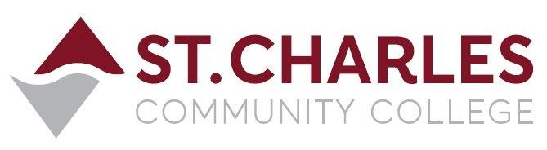
St. Charles Community College
Campus Police Outreach Task Force
Monday April 18th, 2022 at 2:00pm via Zoom
MEETING MINUTES
Lt. Jeff Drake (Chair) Campus Police
Corp. Brandon Misher Campus Police
Chief Bob Ronkoski Campus Police
Disp. Cindy Mulford Campus Police
Stacie Zellin PreventEd
Ryan Pendergast Student Gov. Pres.
Brian Wiltowski Int’l. Student Services

- Welcome to the Group Brandon Misher
• Brandon welcomed everyone, and introduced guest speaker – Stacie Zellin with PreventEd (formerly the National Council on Alcoholism & Drug Abuse – NCADA)

- Presentation on Overdose Prevention and Naloxone Adm. Stacie Zellin
• Stacie introduced the program with definition and signs of overdose
• About PreventEd – Education, Intervention and Advocacy
• Brain science regarding opioid addiction
• Dopamine (pleasure hormone) effects of food, nicotine, and opioids
• Elevated risk factors for people becoming addicted to opioids
• Proven treatments for opioid addiction (Methadone, Buprenorphine, Naltrexone)
• How to identify and respond to opioid overdose
• How to administer Narcan (nasal method of Naloxone)
• Statistics on overdose deaths by zip code, and how Naloxone saves lives

- Questions: From the group
• Stacie was asked about the expiration date of Narcan, she explained if it is properly stored it can last up to 5 years past its expiration date, and instead of disposing of expired Narcan there are agencies that will take it and use it. She was also asked if PreventEd took patients with or without insurance, and she explained that they were a referral service after assessing a patient’s status and the best type of treatment or counseling for them.

Next Meeting is Monday May 2nd, 2022 at 2:00pm via Zoom

