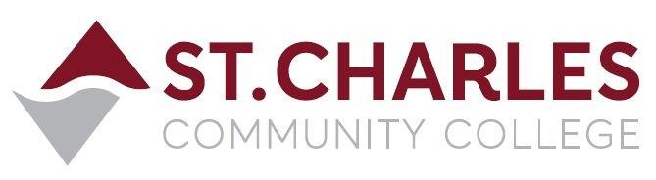
St. Charles Community College
Campus Police Outreach Task Force
Wednesday March 9th, 2022 at 2:00pm via Zoom
MEETING MINUTES
Lt. Jeff Drake (Chair) Campus Police
Capt. Mark Cox Campus Police
Corp. Brandon Misher Campus Police
Disp. Cindy Mulford Campus Police
Brian Wiltowski Int’l. Student Services
James Bratcher Student Life Manager
Christal Thomas Academic Advisor
Ryan Pendergast Student

- Welcome to the Group Jeff Drake
• Jeff welcomed people to the meeting, and introduced guest speaker Brian Wiltowski, current SCC International Student Services Specialist and retired US Customs Agent.

- Presentation on Safe Travel and Other Topics Brian Wiltowski
• Brian spoke to the group about his career in Customs Enforcement and related duties in the United States and other countries. He discussed the potential for getting into trouble while visiting other countries, and that the US Embassies are good sources of information on international travel restrictions and best practices.
• Brian also discussed the problems that international students can encounter when they violate the restrictions that accompany their F-1 student visas.

- Questions Group
• There were no additional questions from the group.

Next Meeting is Monday March 14th, 2022 at 2:00pm via Zoom

