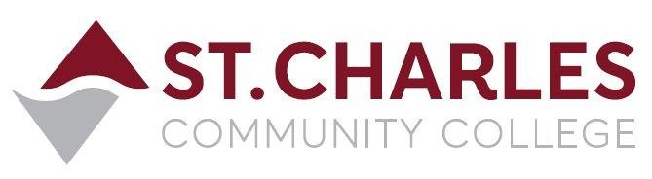

ST. CHARLES COMMUNITY COLLEGE
Campus Police Outreach Task Force
Tuesday October 19th, 2021, at 10:00am
Outside Speaker Presentation via Zoom

MEETING MINUTES

Attendance: (51)

Lt. Jeff Drake (Chair) Sheila Hunt (Guest Presenter) Capt. Mark Cox
Cpl. Brandon Misher Chief Bob Ronkoski Officer Tom Forgue Disp. Cindy Mulford Disp. Char Valenti Martha Garcia Kampen
Erin Schnurbusch Kelly DeGeare Teresa Drury Mitch Harden’s class (27 total) Nick Wallace Todd Galbierz Heather McDorman Dave Bayless Lisa Stoner
Aliesha Suchora Charlene Jones Jenny Hahn Schnipper
Mike Fuszner Crystal Sivia Barb Panosh Kaylie Ross (CenterPointe)

- Welcome / Introductions Jeff Drake
- Jeff welcomed everyone and introduced the Campus Police Outreach Task Force and its mission and introduced Captain Mark Cox and Corporal Brandon Misher to the group.

- Public Speaker Sheila Hunt, MA, LPC
- Sheila Hunt, MA, LPC – Regional Director of Business Development for CenterPointe Health Systems offered a program on Suicide Awareness and Prevention. The topics included:

  - Current statistics on youth suicide and attempts
  - Common myths about youth suicide
  - 5 warning signs associated with suicidal thoughts
  - How to help a friend who is depressed or contemplating suicide
  - Resources to help at-risk college students
  - Do’s and Don’ts’ when talking to someone who is suicidal
  - Signs of depression
  - Elevated risk factors
  - Where to find help
  - Suicide Hotline number (800) 273-TALK [8255]

- Q & A Sheila Hunt
- Sheila answered questions from the attendees and asked them to share contact information on organizations that help people in crisis. The attendees shared phone numbers and websites that offer counseling and response services in the chat room of the Zoom meeting.

- Final Thoughts
- Sheila recapped the general information and resources from her presentation. Jeff thanked her for speaking and asked if she would consider future programs and she said she would be happy to participate whenever we need her.

Next meeting or presentation will be in mid-November 2021 (date TBA)

